Task on Relational Database Service
- Create MariaDB DB on EC2.
Step 1: Launch an EC2 Instance
- Login to AWS Console → Navigate to EC2 Dashboard → Click Launch Instance.
- Choose AMI: Select Amazon Linux 2 (or Ubuntu 22.04 LTS).
- Choose Instance Type: e.g., t2.micro (for testing, free tier eligible).
- Configure Instance Details:
  - Default VPC and subnet are fine for testing.
- Add Storage: Default 8–10 GB is sufficient.
- Add Tags (optional): Name it MariaDB-EC2.
- Configure Security Group:
  - Add SSH (port 22) → Source: your IP.
  - Add MariaDB (port 3306) → Source: your IP or private subnet if accessed internally.
- Review & Launch: Use an existing key pair or create a new one for SSH access.
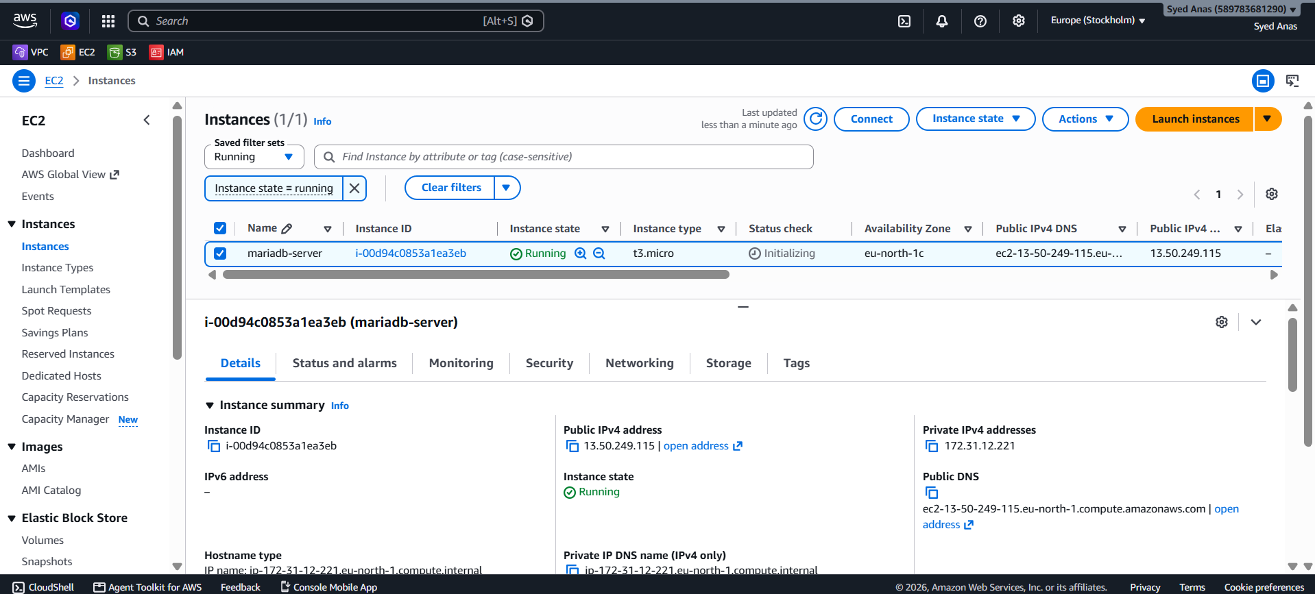
Step 2: Connect to EC2 via SSH
Use your terminal (Linux/macOS) or PuTTY (Windows) to connect:
ssh -i "your-key.pem" ec2-user@<EC2_PUBLIC_IP>
- Replace "your-key.pem" with your key file.
- Replace <EC2_PUBLIC_IP> with the public IP of the EC2 instance.

Step 3: Update the System
Update your packages before installation:
sudo yum update -y -> For Amazon Linux
or for Ubuntu
sudo apt update && sudo apt upgrade -y
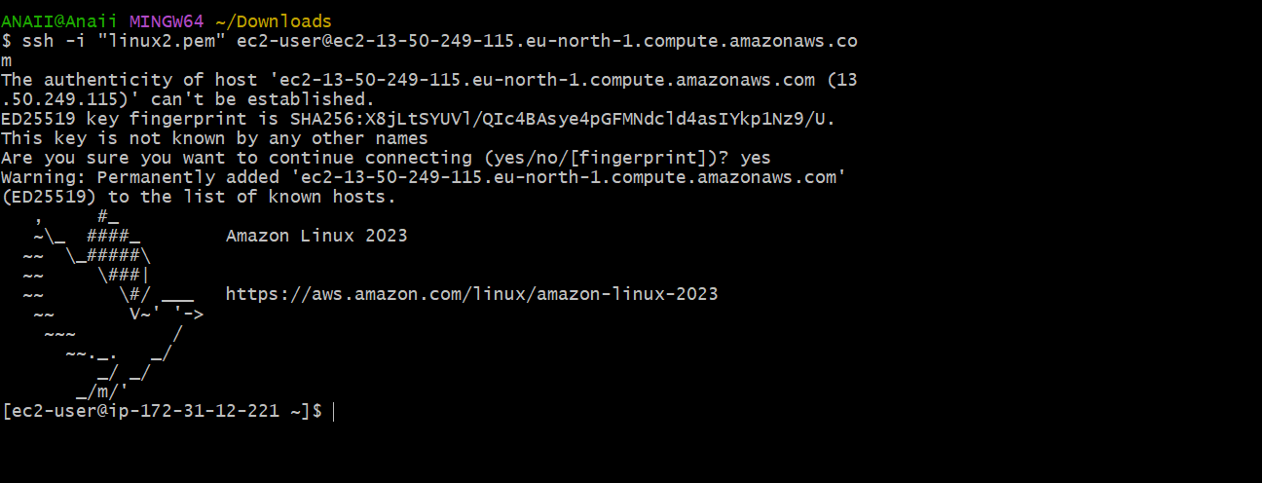
Step 4: Install MariaDB
Install MariaDB server on the EC2 instance.
Amazon Linux 2:
sudo amazon-linux-extras enable mariadb10.5
sudo yum install mariadb-server -y
Ubuntu:
sudo apt install mariadb-server mariadb-client -y

Step 5: Start and Enable MariaDB Service
Start the database and ensure it starts on boot:
sudo systemctl start mariadb
sudo systemctl enable mariadb
sudo systemctl status mariadb
You should see the status as active (running).
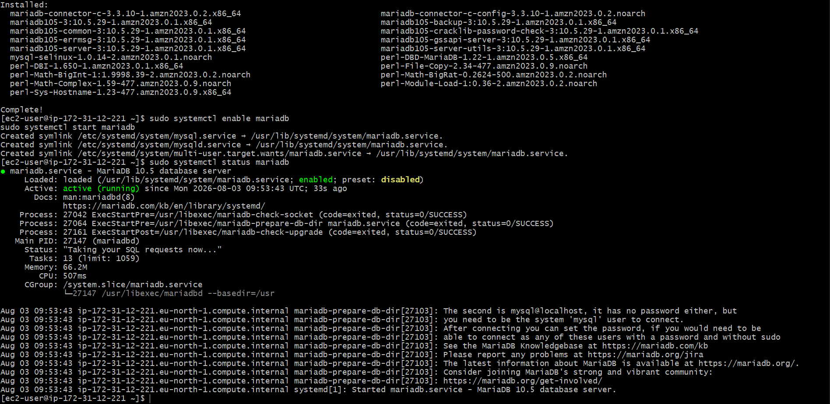

Step 6: Secure MariaDB Installation
MariaDB comes with a script to set root password, remove test databases, etc.
sudo mysql_secure_installation
Steps in the script:
- Set root password → Enter strong password.
- Remove anonymous users → Y.
- Disallow root login remotely → Y (optional, for security).
- Remove test database → Y.
- Reload privilege tables → Y.

Step 7: Access MariaDB
Login to MariaDB as root:
sudo mysql -u root -p
Enter the password you set during secure installation.

Step 8: Create a Database and User
Inside MariaDB shell:
-- Create a new database
CREATE DATABASE mydatabase;

-- Create a new user
CREATE USER 'dbuser'@'%' IDENTIFIED BY 'StrongPassword123';

-- Grant privileges
GRANT ALL PRIVILEGES ON mydatabase.* TO 'dbuser'@'%';

-- Apply privileges
FLUSH PRIVILEGES;

-- Exit
EXIT;

Step 9: Configure Remote Access (Optional)
If you want to access MariaDB from outside the EC2 instance:
- Edit MariaDB config:
sudo vi /etc/my.cnf # Amazon Linux
# or Ubuntu: sudo vi /etc/mysql/mariadb.conf.d/50-server.cnf

- Change bind-address from 127.0.0.1 to 0.0.0.0:
bind-address = 0.0.0.0
- Restart MariaDB:
sudo systemctl restart mariadb
- Ensure Security Group allows 3306 from your IP.

Step 10: Test Database Connection
From another machine (or local client):
mysql -h <EC2_PUBLIC_IP> -u dbuser -p
Enter the password → You should connect successfully.

✅ MariaDB is now fully installed and accessible on EC2!

- Insert some dummy data.
Step 1: Connect to Your Database
- SSH into your EC2 instance if your database is hosted there:
- ssh -i your-key.pem ec2-user@your-ec2-public-ip
- Log in to MariaDB/MySQL:
- mysql -u root -p
  - Enter your database password.
- Select the database you created earlier:
- USE your_database_name;

Step 2: Create a Table (if not already created)
Assume we want to insert dummy user data. First, create a users table:
CREATE TABLE IF NOT EXISTS users (
id INT AUTO_INCREMENT PRIMARY KEY,
name VARCHAR(50),
email VARCHAR(50),
age INT,
created_at TIMESTAMP DEFAULT CURRENT_TIMESTAMP
);
- id → unique identifier
- name → user's name
- email → user's email
- age → user's age
- created_at → timestamp when the row was inserted

Step 3: Insert Dummy Data Manually
You can insert a single row like this:
INSERT INTO users (name, email, age)
VALUES ('John Doe', 'john.doe@example.com', 30);
Insert multiple rows at once:
INSERT INTO users (name, email, age) VALUES
('Alice Smith', 'alice@example.com', 25),
('Bob Johnson', 'bob@example.com', 28),
('Charlie Brown', 'charlie@example.com', 32);

Step 4: Insert Dummy Data Using a Loop (Optional)
For testing, you might want 100+ dummy rows. MariaDB/MySQL allows loops using stored procedures or via scripts.
Example using a stored procedure:
DELIMITER $$

CREATE PROCEDURE insert_dummy_users()
BEGIN
DECLARE i INT DEFAULT 1;
WHILE i <= 50 DO
INSERT INTO users (name, email, age)
VALUES (CONCAT('User', i), CONCAT('user', i, '@example.com'), FLOOR(20 + RAND()*30));
SET i = i + 1;
END WHILE;
END$$

DELIMITER ;

-- Call the procedure
CALL insert_dummy_users();
- CONCAT('User', i) → generates names like User1, User2, etc.
- CONCAT('user', i, '@example.com') → generates emails like user1@example.com
- FLOOR(20 + RAND()*30) → random age between 20–50

Step 5: Verify Data Inserted
Check the inserted data:
SELECT * FROM users;
You should see all the dummy rows you inserted.
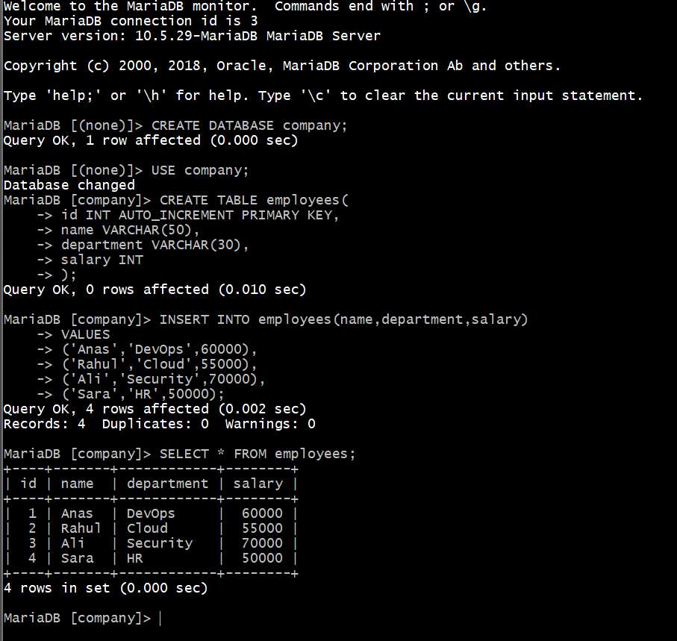
- Take the backup of dummy data on EC2.
Step 1: Connect to your EC2 instance
- Open a terminal on your local machine.
- Use SSH to connect:
ssh -i /path/to/your-key.pem ec2-user@<EC2_PUBLIC_IP>
- Replace /path/to/your-key.pem with the path to your private key.
- Replace <EC2_PUBLIC_IP> with your EC2 instance public IP.

Step 2: Locate your dummy data
- Let’s say your dummy data is in /home/ec2-user/dummy_data/.
- Verify the files:
ls -l /home/ec2-user/dummy_data/

Step 3: Decide backup strategy
There are multiple ways to back up data:
- Local backup on the same EC2 (tar/zip):
  - Simple, compress and store locally.
- Remote backup to S3:
  - Safer, durable, can restore even if EC2 is lost.
- Snapshot backup (for entire disk):
  - Useful if you want a full system snapshot.
We will go through both local compressed backup and S3 backup.

Step 4: Create a compressed backup (tar.gz)
- Navigate to the parent directory of your dummy data:
cd /home/ec2-user/
- Create a compressed archive:
tar -czvf dummy_data_backup_$(date +%F).tar.gz dummy_data/
- tar = tool to create archives.
- -c = create archive.
- -z = compress using gzip.
- -v = verbose (show progress).
- -f = specify filename.
- $(date +%F) = automatically adds date in YYYY-MM-DD format to filename.
- Verify the backup:
ls -lh dummy_data_backup_*.tar.gz

Step 5: Backup to Amazon S3 (optional but recommended)
- Install AWS CLI (if not installed):
sudo apt-get update && sudo apt-get install awscli -y # Ubuntu/Debian
# OR
sudo yum install awscli -y # Amazon Linux/RedHat
- Configure AWS CLI:
aws configure
- Enter your AWS Access Key ID, Secret Access Key, region, and output format (e.g., json).
- Upload backup to S3:
aws s3 cp dummy_data_backup_$(date +%F).tar.gz s3://your-bucket-name/
- Replace your-bucket-name with your S3 bucket.
- Verify upload:
aws s3 ls s3://your-bucket-name/

Step 6: Automate the backup (optional)
- Use cron to automatically back up your data daily:
crontab -e
Add the line:
0 2 * * * tar -czvf /home/ec2-user/dummy_data_backup_$(date +\%F).tar.gz /home/ec2-user/dummy_data/ && aws s3 cp /home/ec2-user/dummy_data_backup_$(date +\%F).tar.gz s3://your-bucket-name/
- This runs every day at 2 AM.

Step 7: Test backup and restore
- Test the archive:
tar -tzvf dummy_data_backup_YYYY-MM-DD.tar.gz
- To restore:
tar -xzvf dummy_data_backup_YYYY-MM-DD.tar.gz -C /home/ec2-user/
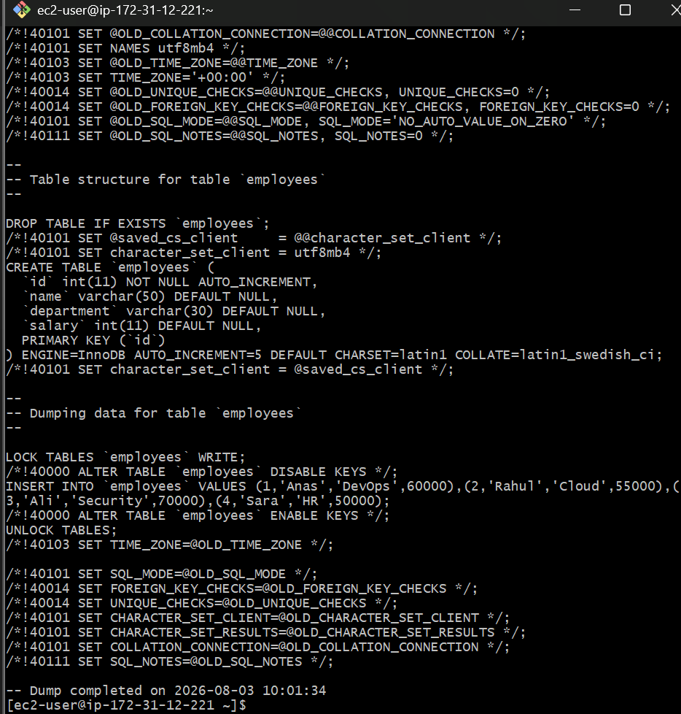

✅ Summary:
- Connected to EC2 using SSH.
- Compressed dummy data into a .tar.gz file.
- Uploaded backup to S3 for safe storage.
- Optionally automated backup with cron.

- Launch MariaDB RDS instance.
Step 1: Decide Instance Details
Before creating RDS, you need to define:
- DB Engine: MariaDB
- Version: Choose the latest stable version (e.g., 11.x)
- DB Instance Class: e.g., db.t3.micro (for testing) or db.t3.medium (for production)
- Storage Type: General Purpose SSD (gp2/gp3)
- Allocated Storage: Minimum 20 GB for testing
- Multi-AZ Deployment: Optional for high availability
- DB Name: e.g., mydatabase
- Master Username / Password: Note them down securely

Step 2: Launch via AWS Console
- Go to AWS Console → RDS → Databases → Create database.
- Select:
  - Engine type: MariaDB
  - Templates: Choose Production or Dev/Test
- Configure DB settings:
  - DB instance identifier: my-mariadb-rds
  - Master username: admin
  - Password: Admin@123 (example)
- Configure instance size:
  - db.t3.micro (free tier if eligible)
  - Storage: 20 GB (GP2)
- Connectivity:
  - VPC: Select your existing VPC
  - Subnet group: default or custom (should include private/public subnets)
  - Public access: Yes (if you want EC2 to connect from public network, otherwise No)
  - VPC Security group: Choose or create one allowing port 3306
- Additional configuration:
  - Backup retention: 7 days (default)
  - Monitoring: Enable if needed
  - Maintenance: Optional
- Click Create Database
  - Wait 10–15 minutes for the RDS instance to be available.

Step 3: Note Connection Details
Once created:
- Endpoint: e.g., my-mariadb-rds.abcd1234.us-east-1.rds.amazonaws.com
- Port: 3306
- Username / Password: As defined during setup
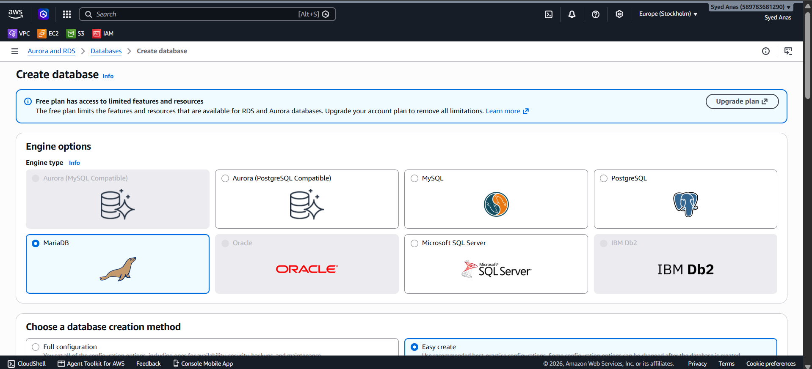
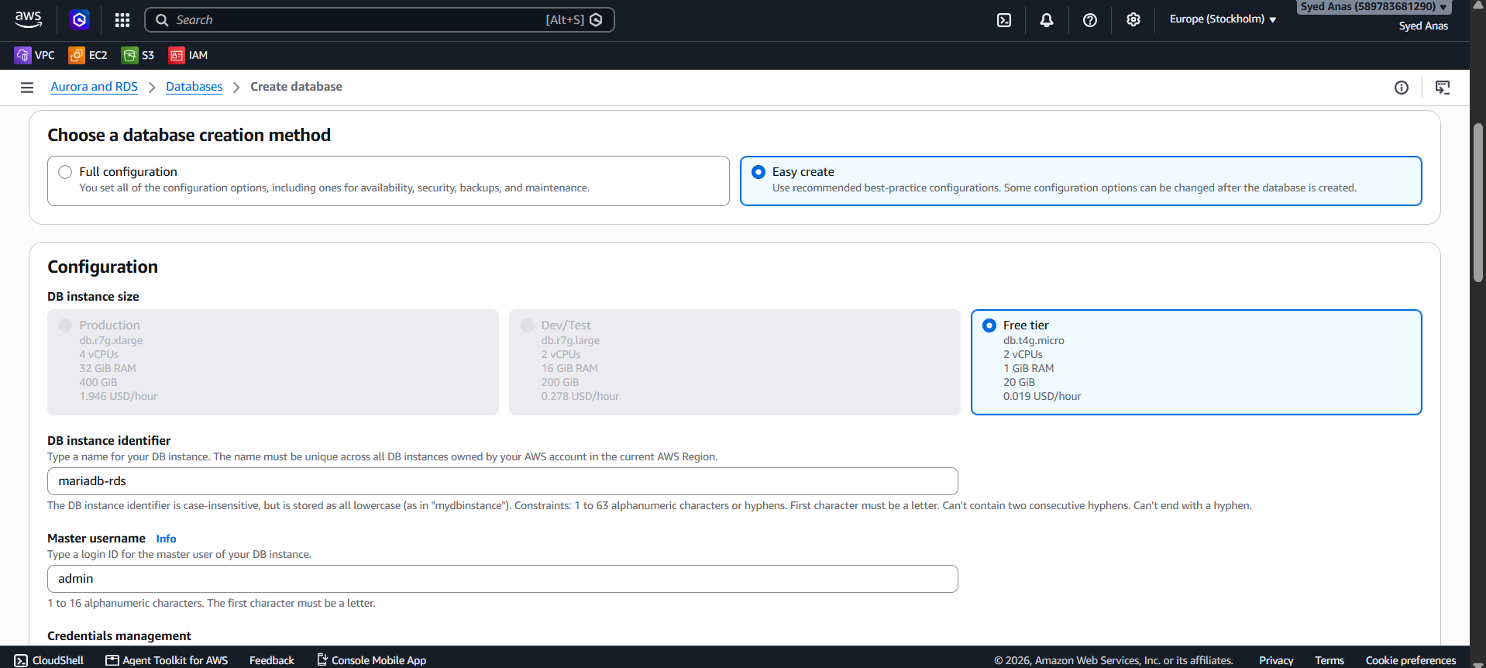
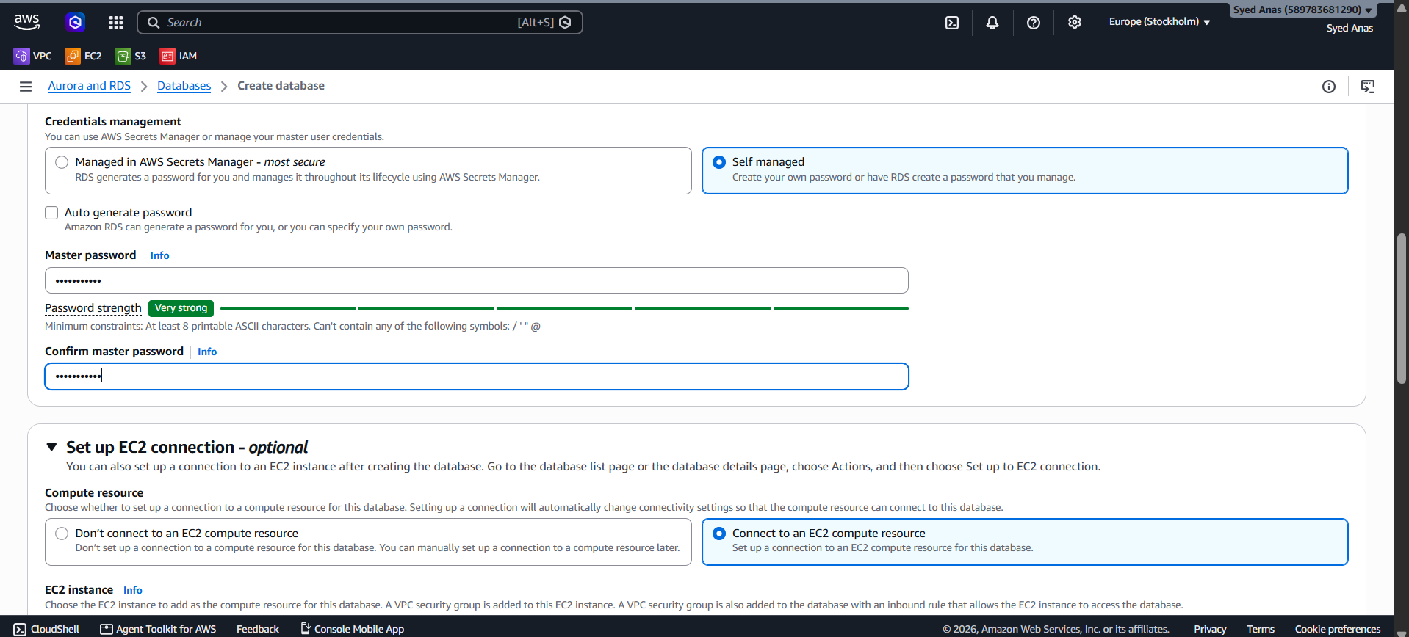
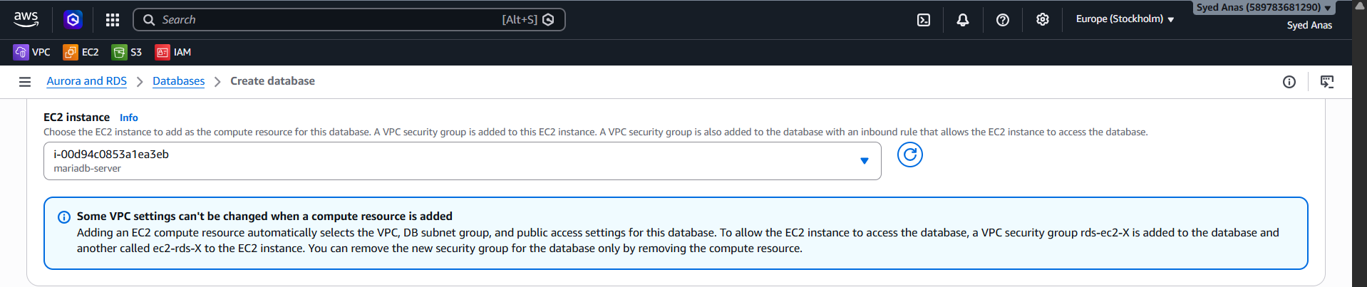
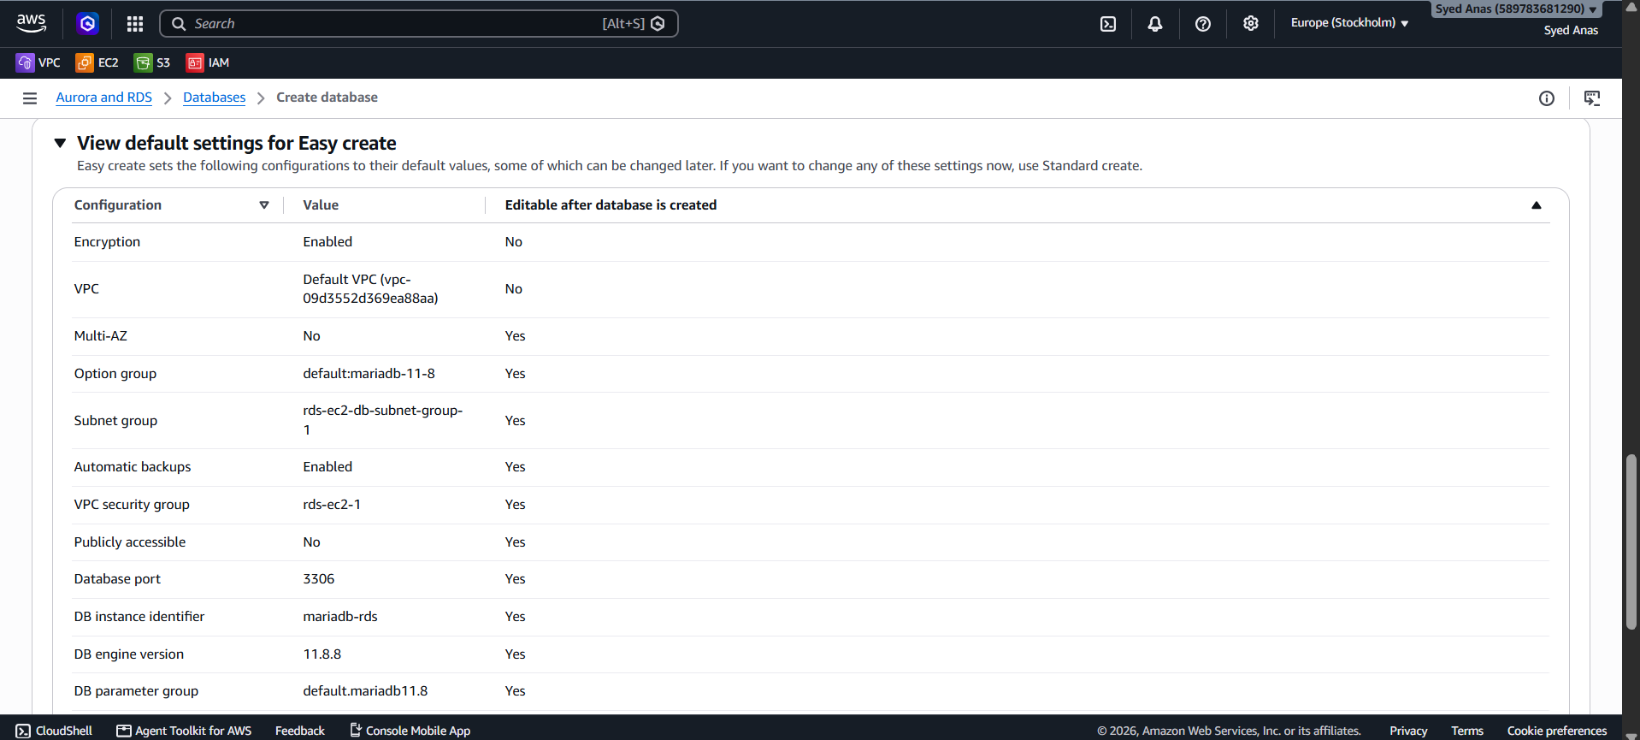
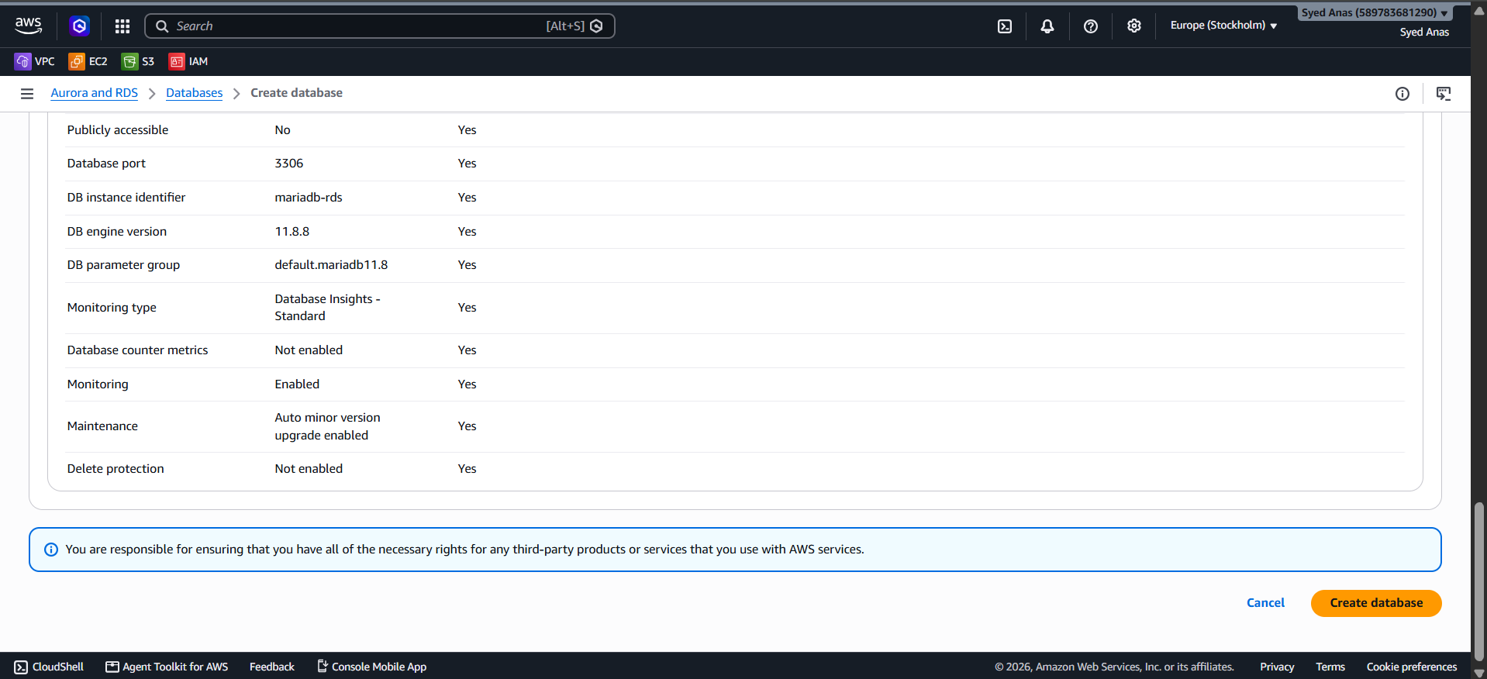
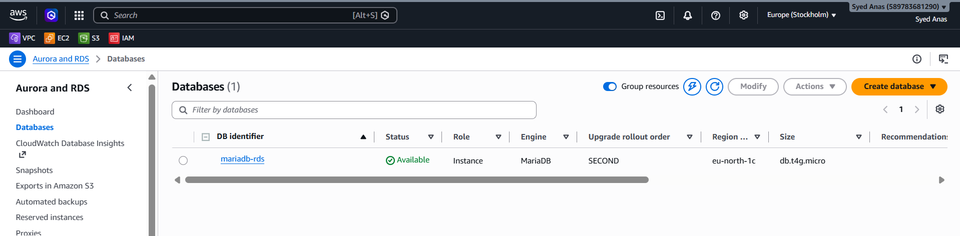

- Migrate database from EC2 to RDS.
Using mysqldump (Simple and Reliable)
Step 1: Export Database from EC2
- SSH into your EC2 instance:
- ssh ec2-user@<EC2_PUBLIC_IP>
- Dump your database:
- mysqldump -u root -p mydatabase > mydatabase.sql
  - This creates a mydatabase.sql file with your DB data.

Step 2: Import Database into RDS
- Ensure EC2 can reach RDS (security group of RDS allows EC2’s IP or security group on port 3306)
- Run import command:
- mysql -h <RDS_ENDPOINT> -P 3306 -u admin -p mydatabase < mydatabase.sql
- Verify data:
- mysql -h <RDS_ENDPOINT> -P 3306 -u admin -p
- SHOW DATABASES;
- USE mydatabase;
- SHOW TABLES;
✅ Database is now migrated from EC2 to RDS.

Option 2: Using AWS DMS (For Large or Continuous Migrations)
AWS Database Migration Service can migrate databases live with minimal downtime.
- Create a Replication Instance in DMS.
- Configure Source Endpoint → EC2 MariaDB
- Configure Target Endpoint → RDS MariaDB
- Create a Migration Task (full load + ongoing changes if needed)
- Start the migration; monitor progress in DMS console.

Step 3: Update Applications
- Change your application’s database endpoint to the RDS endpoint.
- Test connectivity and data integrity.
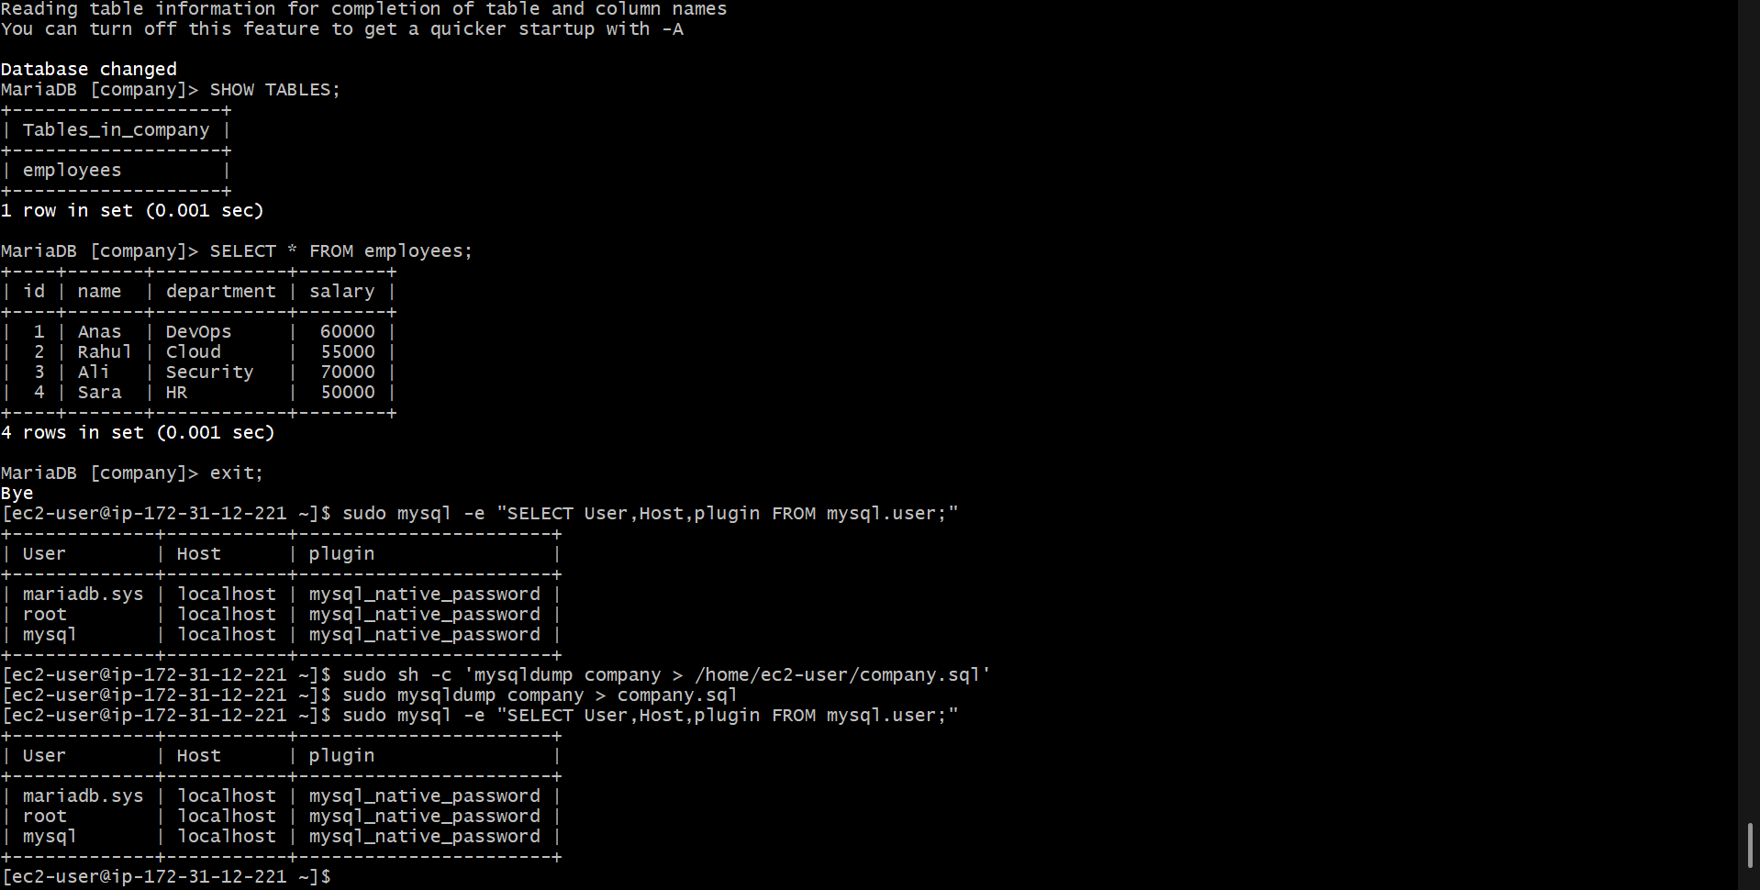

- Install MySQL DB on EC2.
Step 1: Launch an EC2 Instance
- Go to AWS Management Console → EC2 → Launch Instances.
- Choose an AMI:
  - For Linux, select Amazon Linux 2 or Ubuntu Server 22.04 LTS.
- Choose an instance type:
  - t2.micro (for testing) or higher depending on your load.
- Configure network & security:
  - Assign a security group allowing:
    - SSH (port 22) from your IP.
    - MySQL (port 3306) from trusted IPs or security groups.
- Launch the instance and note its public IP.

Step 2: Connect to EC2 via SSH
- Open terminal or use PuTTY (Windows).
- Run:
- ssh -i /path/to/your-key.pem ec2-user@<EC2_PUBLIC_IP>
  - Replace /path/to/your-key.pem with your private key path.
  - Replace <EC2_PUBLIC_IP> with your EC2 IP.

Step 3: Update Packages
Before installing MySQL, update the OS packages.
Amazon Linux 2:
sudo yum update -y
Ubuntu:
sudo apt update && sudo apt upgrade -y

Step 4: Install MySQL
Option A: Amazon Linux 2 / RHEL / CentOS
- Enable MySQL repository:
sudo amazon-linux-extras enable mariadb10.5
- Install MySQL server:
sudo yum install mariadb-server -y
- Start MySQL service:
sudo systemctl start mariadb
sudo systemctl enable mariadb
Option B: Ubuntu
- Install MySQL server:
sudo apt install mysql-server -y
- Start MySQL service:
sudo systemctl start mysql
sudo systemctl enable mysql

Step 5: Secure MySQL Installation
Run the secure installation script:
sudo mysql_secure_installation
You will be prompted to:
- Set root password
- Remove anonymous users
- Disallow root login remotely
- Remove test database
- Reload privilege tables
Recommendation: Answer Yes to all for security.

Step 6: Verify MySQL Installation
- Check service status:
sudo systemctl status mysql # Ubuntu
sudo systemctl status mariadb # Amazon Linux
- Login to MySQL:
sudo mysql -u root -p
- Create a test database:
CREATE DATABASE test_db;
SHOW DATABASES;
EXIT;

Step 7: Configure MySQL for Remote Access (Optional)
If you want to access MySQL from another machine:
- Edit MySQL config file:
sudo nano /etc/mysql/mysql.conf.d/mysqld.cnf # Ubuntu
sudo nano /etc/my.cnf # Amazon Linux
- Find bind-address = 127.0.0.1 and change to:
bind-address = 0.0.0.0
- Grant remote access to a user:
CREATE USER 'admin'@'%' IDENTIFIED BY 'StrongPassword123';
GRANT ALL PRIVILEGES ON *.* TO 'admin'@'%' WITH GRANT OPTION;
FLUSH PRIVILEGES;
- Restart MySQL:
sudo systemctl restart mysql
- Ensure port 3306 is allowed in the security group.

Step 8: Backup / Maintenance Tips
- Regularly backup using mysqldump:
mysqldump -u root -p test_db > test_db_backup.sql
- Monitor MySQL logs:
sudo tail -f /var/log/mysqld.log
- Keep MySQL updated via yum or apt.

✅ Your MySQL DB is now ready to use on EC2. You can connect from local clients or application servers.
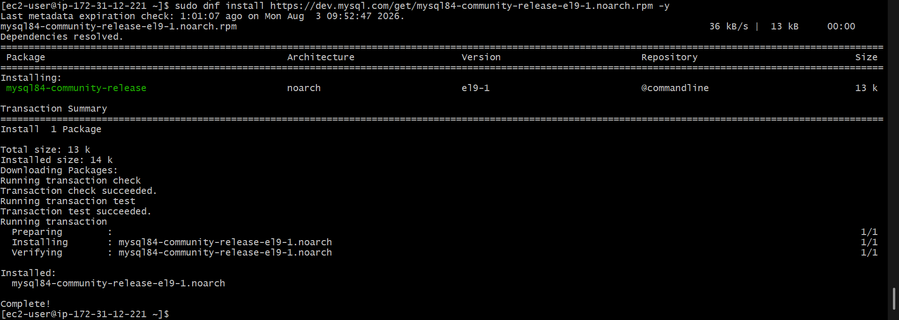
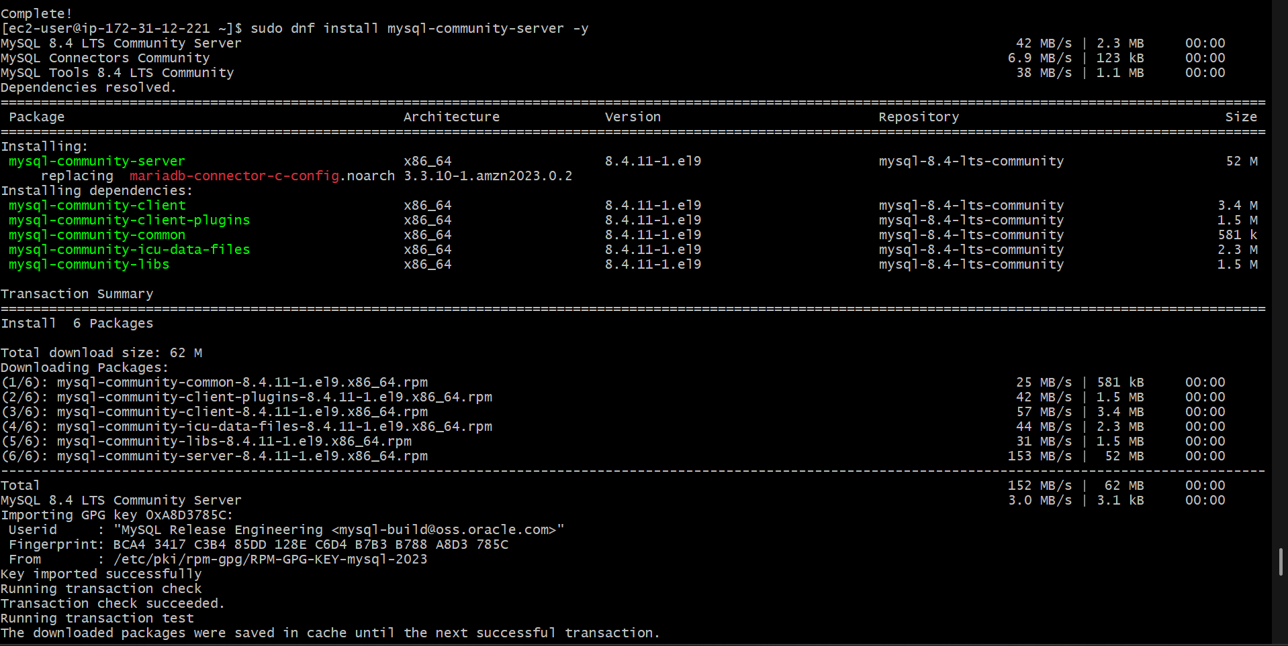
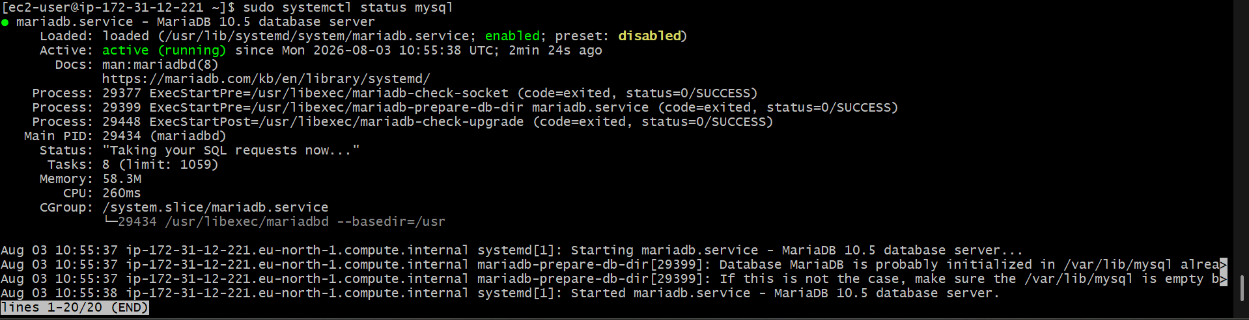

- Launch MySQL RDS image.
Amazon RDS (Relational Database Service) lets you create, manage, and scale relational databases in the cloud. We’ll launch a MySQL RDS instance.
Step 1: Sign in to AWS Management Console
- Go to AWS Management Console → RDS service.
Step 2: Start RDS Instance Creation
- In the RDS dashboard, click Databases → Create database.
- Choose Standard Create (gives more control over configuration).
Step 3: Choose Engine
- Select MySQL as the database engine.
- Choose Version (e.g., MySQL 8.0.x for latest stable version).
Step 4: Choose Use Case
- Select Production if it’s for real workloads.
- Select Dev/Test if it’s for testing purposes.
Step 5: Configure Settings
- DB instance identifier: A unique name for your DB (e.g., mydb-instance).
- Master username: e.g., admin.
- Master password: Set a secure password and confirm it.
Step 6: Choose DB Instance Class
- Instance class defines the compute and memory (e.g., db.t3.medium for small workloads).
- Consider your expected workload.
Step 7: Storage
- Storage type: General Purpose (SSD) is common.
- Allocated storage: e.g., 20 GB or as required.
- Enable Storage autoscaling if you want AWS to automatically increase storage when needed.
Step 8: Configure Connectivity
- VPC: Select the VPC where your application resides.
- Subnet group: Choose a DB subnet group (usually AWS creates one by default).
- Public access: Choose Yes if you want DB accessible from the internet; No for private-only access.
- VPC security group: Select or create a security group allowing MySQL port 3306.
Step 9: Database Options
- DB name: Optional, e.g., mydatabase.
- Port: Default 3306 for MySQL.
- Leave other advanced options for now, unless specific customizations are needed.
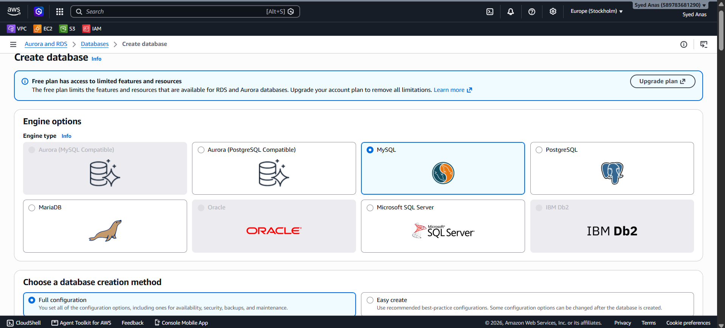
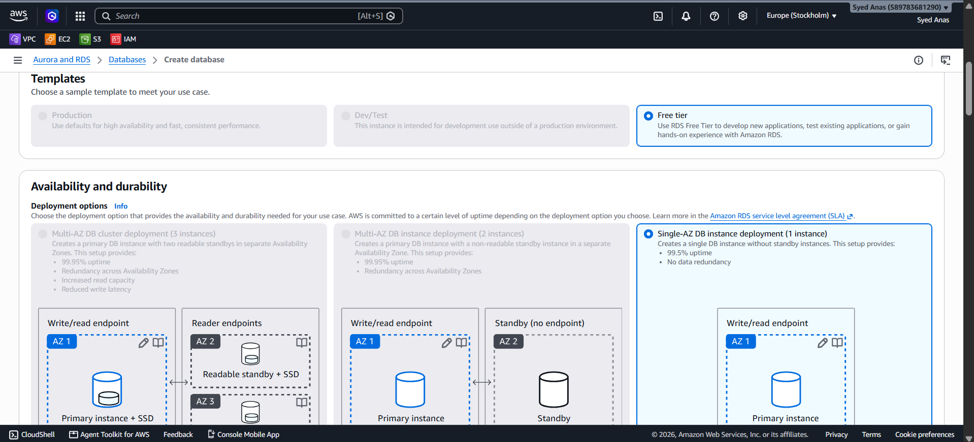
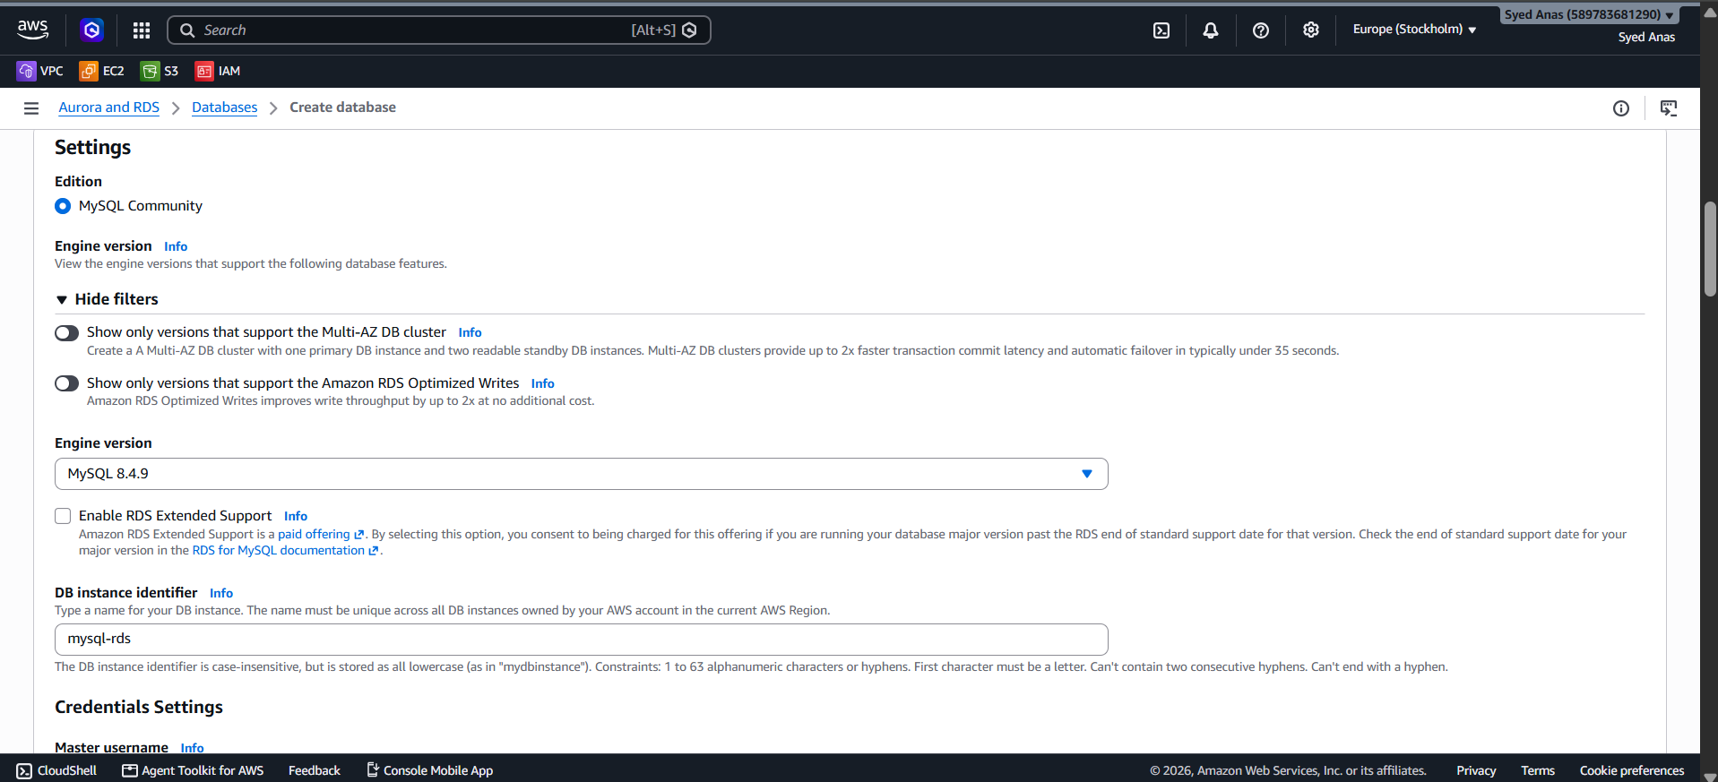
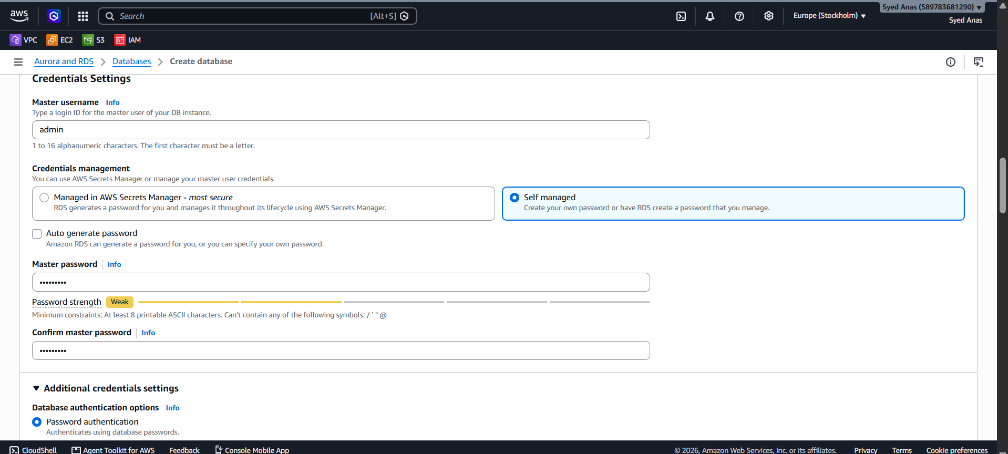
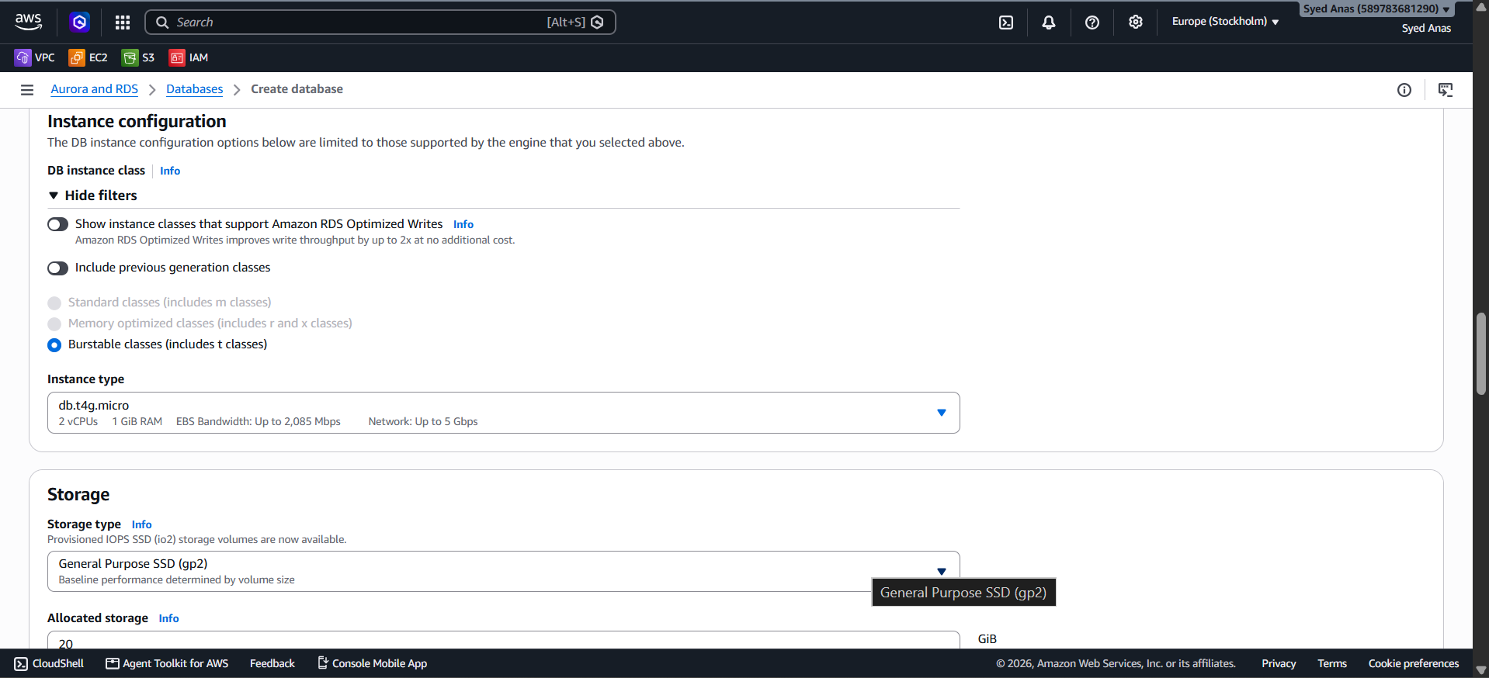
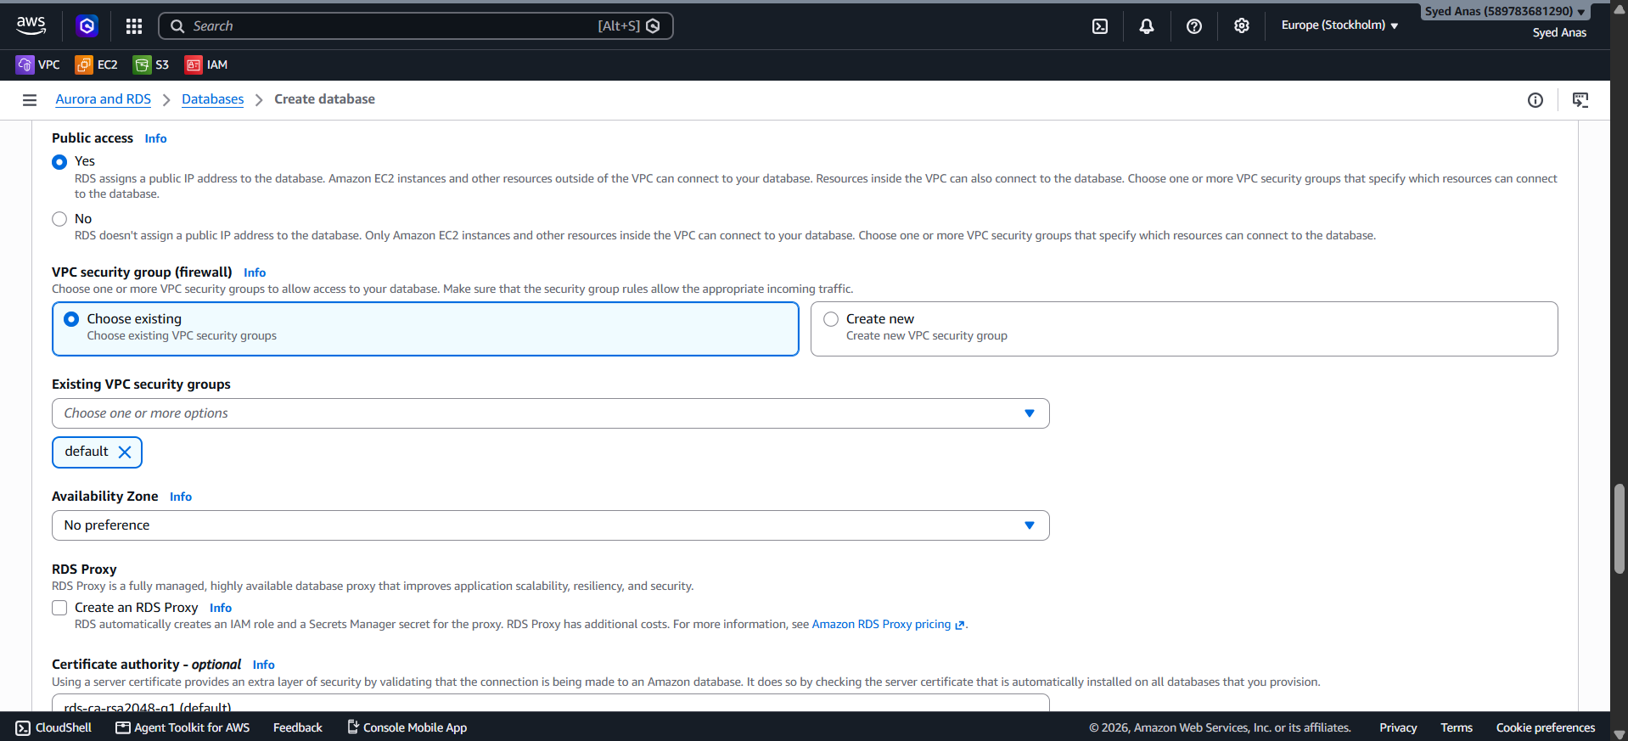
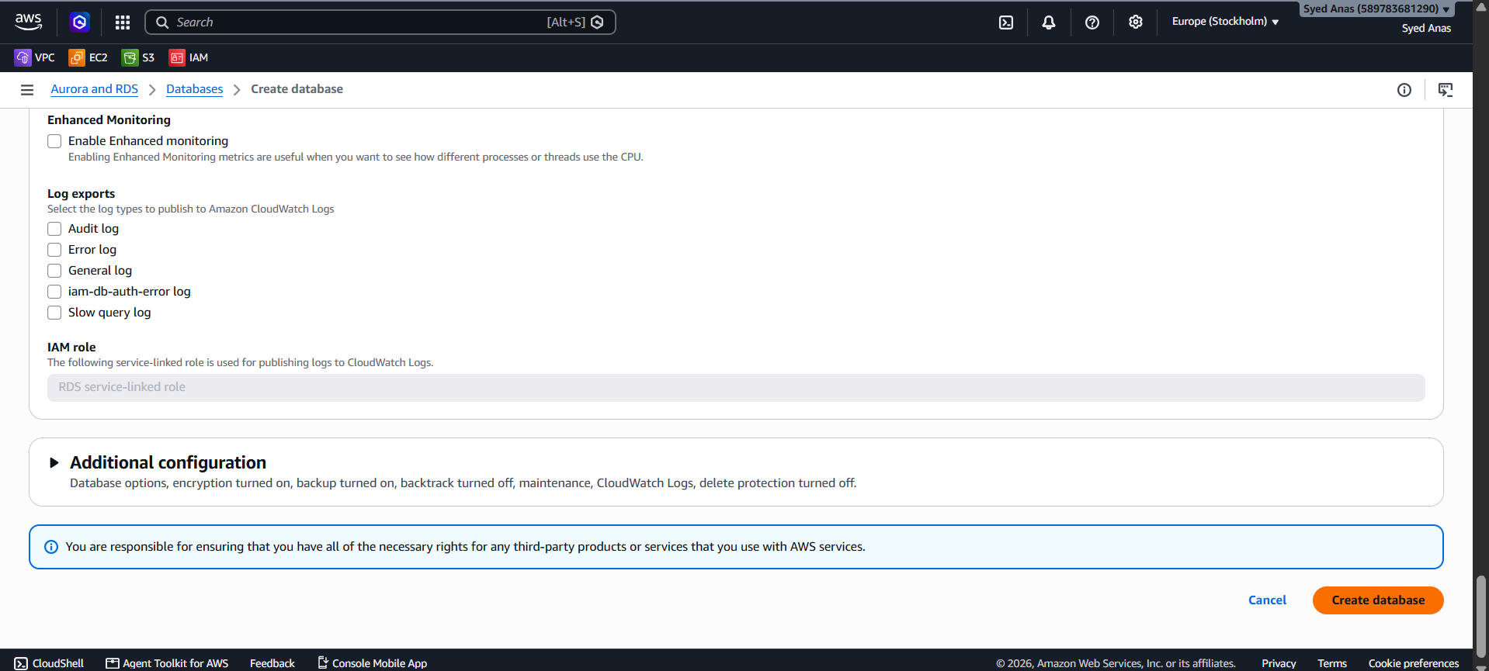
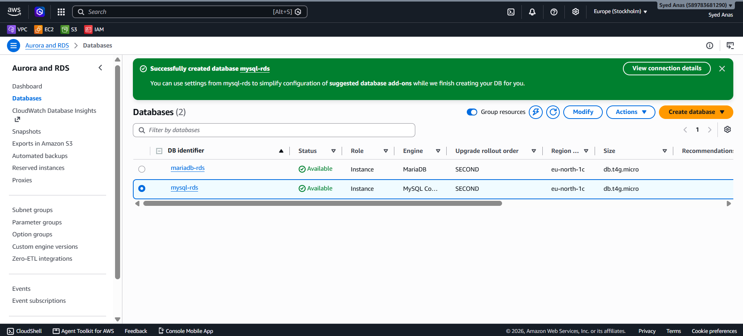

- Configure Multi-AZ.
Multi-AZ ensures high availability by automatically replicating the database to a standby instance in a different Availability Zone. This helps in failover during infrastructure failure.
Step 1: Enable Multi-AZ
- In the Availability & durability section, set Create a standby instance (Multi-AZ) to Yes.
- AWS will automatically select another AZ in the same region for the standby replica.
Step 2: Backup & Maintenance
- Backup retention: Set the number of days for automated backups (e.g., 7 days).
- Enable automatic minor version upgrades to keep MySQL up-to-date.
- Maintenance window: Optional; AWS chooses a default window.

Step 3: Review & Launch
- Review all configurations carefully:
  - DB engine: MySQL
  - Instance class
  - Storage type
  - Multi-AZ: Yes
  - Security groups and VPC
- Click Create database.

Step 4: Connect to Your MySQL RDS
- Find the endpoint of the RDS instance in RDS console → Databases → Click your DB → Connectivity & security → Endpoint.
- Use MySQL client:
mysql -h <RDS-ENDPOINT> -P 3306 -u admin -p
- Enter the password you set during creation.

- Take backup of DB and restore the DB.
- Take Backup of DB and Restore the DB
Step 1: Take a Snapshot (Backup) of the RDS DB
- Go to AWS Management Console → RDS → Databases.
- Select the DB instance you want to backup.
- Click Actions → Take snapshot.
- Enter a Snapshot name.
- Click Take Snapshot.
- The snapshot will appear in Snapshots section. Wait until the status changes to Available.
Optional: Use AWS CLI:
aws rds create-db-snapshot \
--db-snapshot-identifier mydb-snapshot-2025-10-13 \
--db-instance-identifier mydb-instance

Step 2: Restore the DB from Snapshot
- Go to Snapshots → Select your snapshot → Actions → Restore snapshot.
- Provide a new DB instance identifier (you cannot restore over the same instance directly).
- Configure instance size, VPC, and security group as needed.
- Click Restore DB Instance.
- Wait until the status is Available. You now have a restored DB instance.
Optional: AWS CLI:
aws rds restore-db-instance-from-db-snapshot \
--db-instance-identifier mydb-restored \
--db-snapshot-identifier mydb-snapshot-2025-10-13

Step 3: Test the Restored DB
- Connect using a client (MySQL Workbench, CLI, or application) and verify that all data is intact.
mysql -h <restored-endpoint> -u admin -p
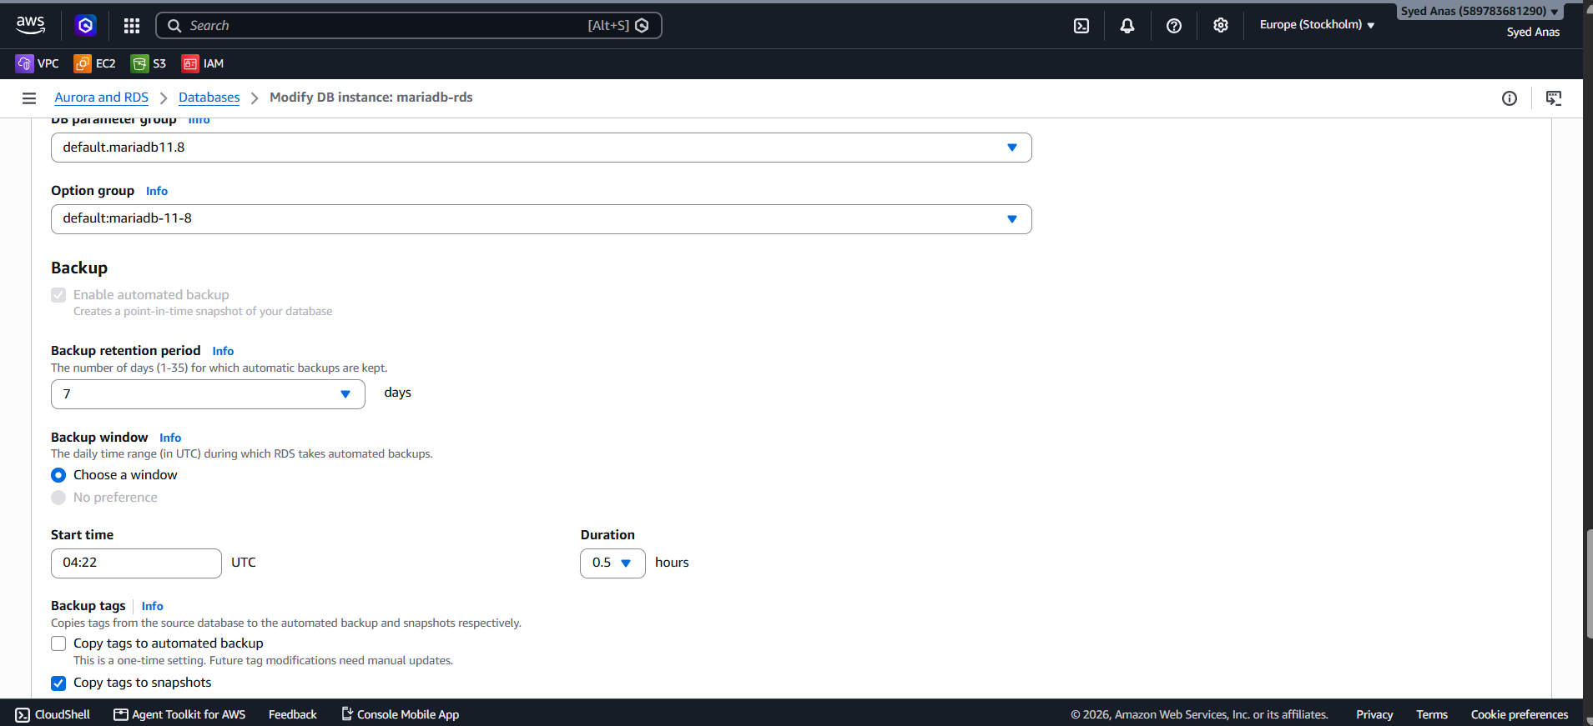
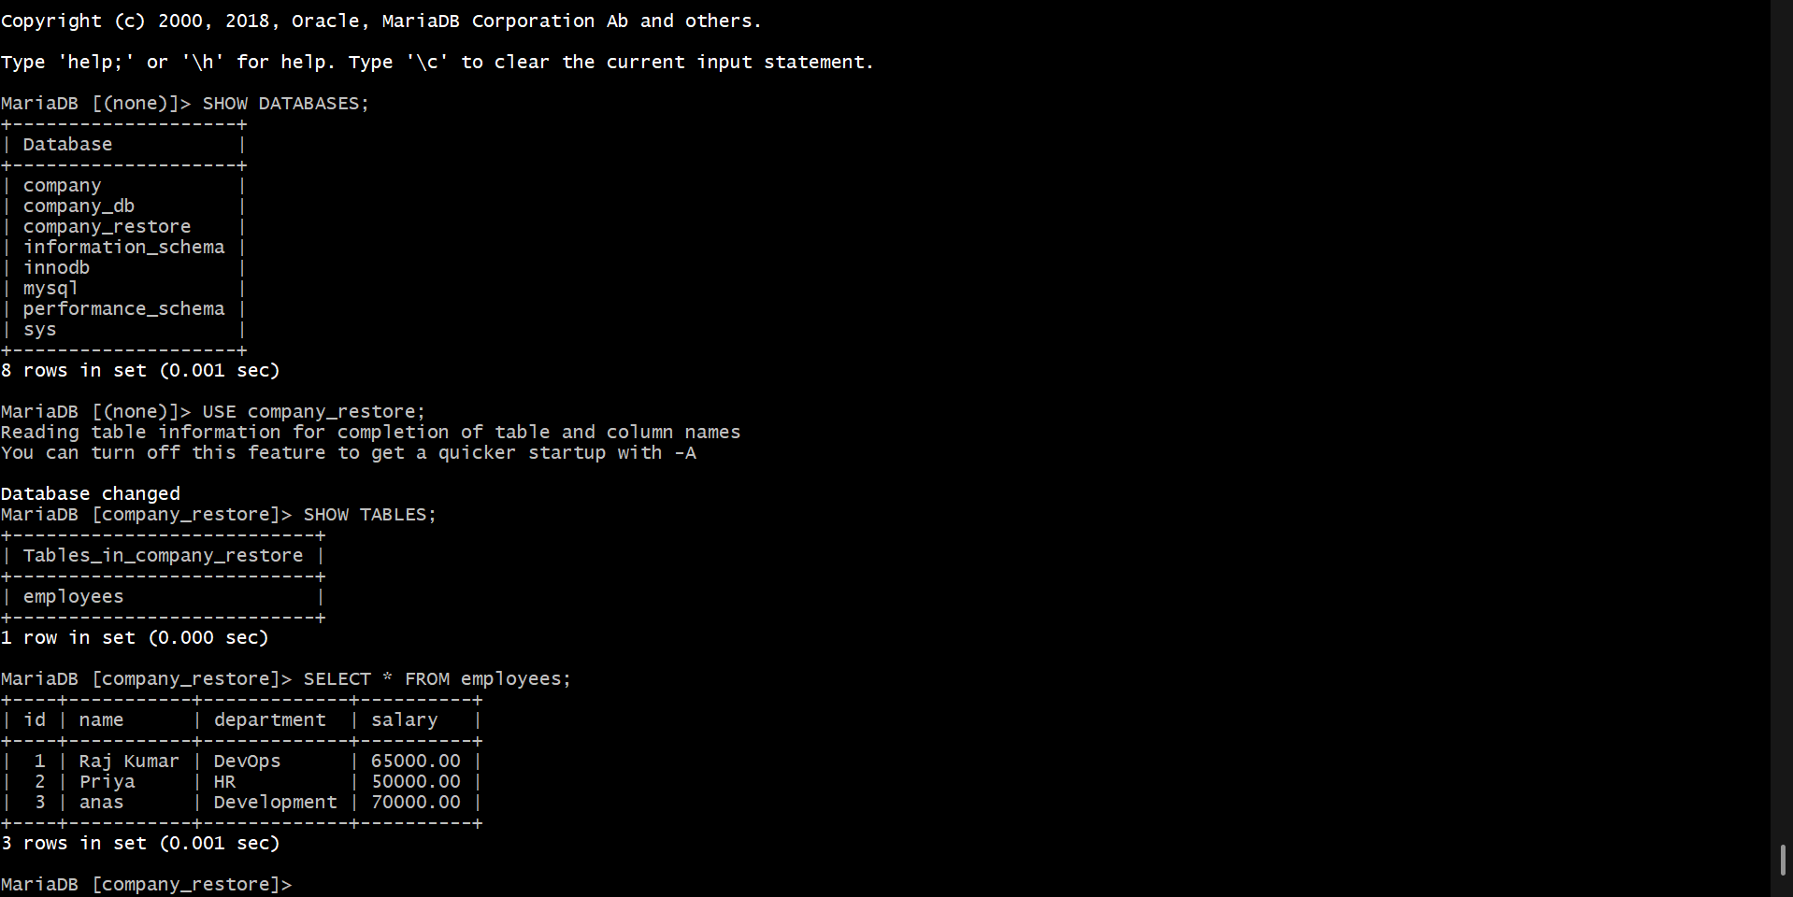

- Create read replica.
Read replicas are used for scaling read operations and disaster recovery.
Step 1: Create Read Replica via Console
- Go to AWS RDS → Databases → Select your DB instance.
- Click Actions → Create read replica.
- Enter a DB instance identifier for the replica.
- Configure:
  - Instance class (e.g., db.t3.medium)
  - Multi-AZ (optional)
  - VPC & Subnet group (usually same as source DB)
- Click Create read replica.
- The read replica will appear in your RDS list. Its status will be Creating and then Available.
Step 2: Connect and Test
- Use the read replica endpoint for read-only operations.
mysql -h <read-replica-endpoint> -u admin -p
- Try SELECT queries to verify data replication.

Notes:
- Backups: Automated backups can also be enabled for continuous snapshots.
- Replication Lag: Small delay may occur between primary DB and read replica.
- Read/Write: Read replicas are read-only. Writes must go to the primary DB.
- Multi-AZ: If high availability is needed, enable Multi-AZ on the primary DB.
